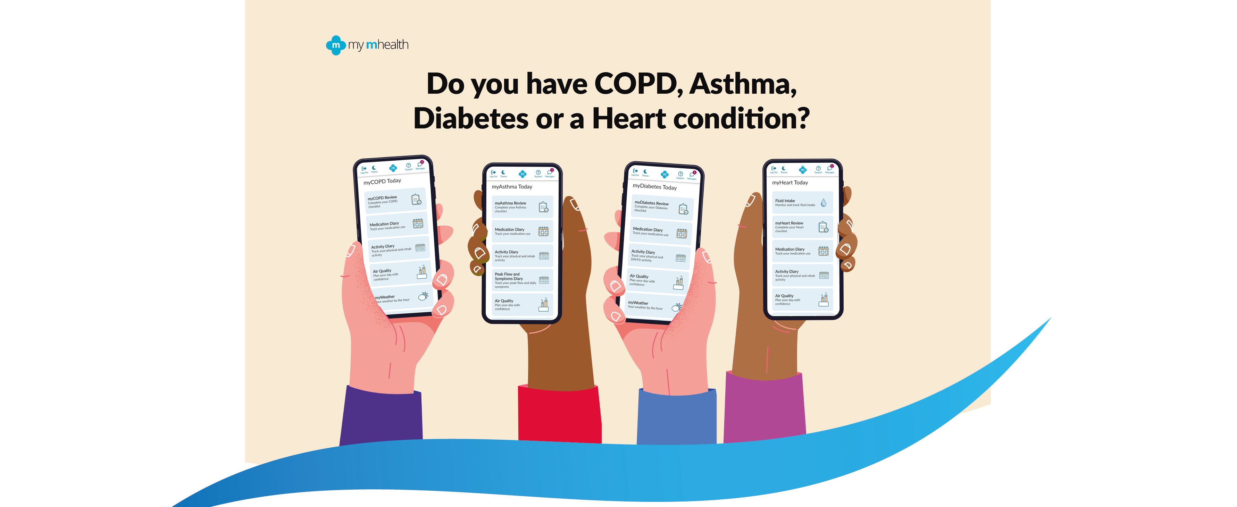

my mhealth’s apps are easy to use but if you need any
help contact your Digital Health Adviser

Your Digital Health Adviser is: xxxxNAMExxxx
xxxxEMAILxxxx or call: xxxxPHONExxxx

Or for technical support contact:
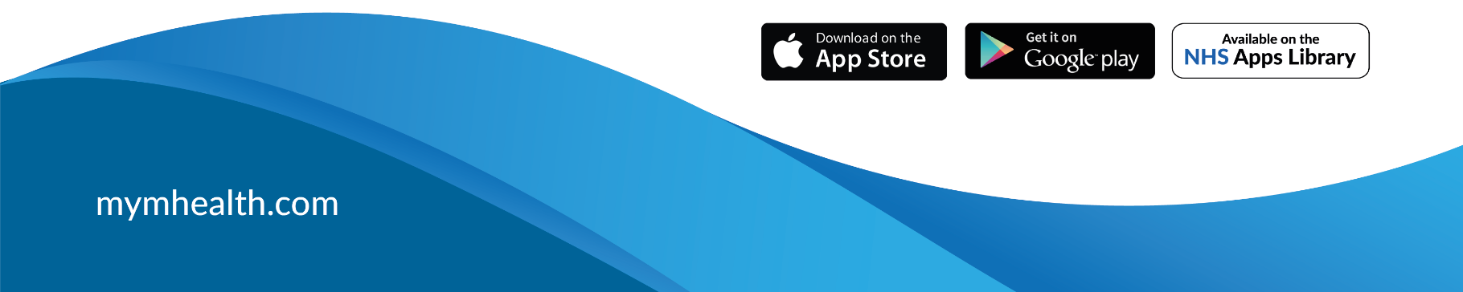
support@mymhealth.com or call: 01202 299583
MYM-[0010][SEP][20]

